Automated Regression Testing On A Web Application
(Test Results Summary)
Demo Assignment: Develop automated test scripts using a test automation framework of your choice. Perform automated regression testing on a web application and analyze the test results. Present your automation approach and discuss the benefits of test automation.
Submit 4 things:
- Laptop screen recording video - 3-4 min with AI voice notes explaining steps
- GitHub link - test scripts + README
- Screenshots - SS of every major step attached, labeled Step 1, Step 2
- 1-page PDF - test result summary
Create simple automated test scripts, for example a login test where you open the browser, enter details, and check the result. The main goal is to show your approach to automation, run regression tests, and present your work clearly through the video, GitHub link, screenshots, and a short summary report.

Automated Regression Testing On A Web Application
(Test Results Summary)
Project: Automated Regression Testing
Website: https://opensource-demo.orangehrmlive.com
GitHub Repository:
Tool Used: Selenium WebDriver with Python in VS Code
Objective:
To automate regression testing of login functionality.
Test Scenario: Valid Login Test or Invalid Login Test
TEST CASE 1: VALID LOGIN
CODE:
Test_valid_login.py (Automatic Testing):
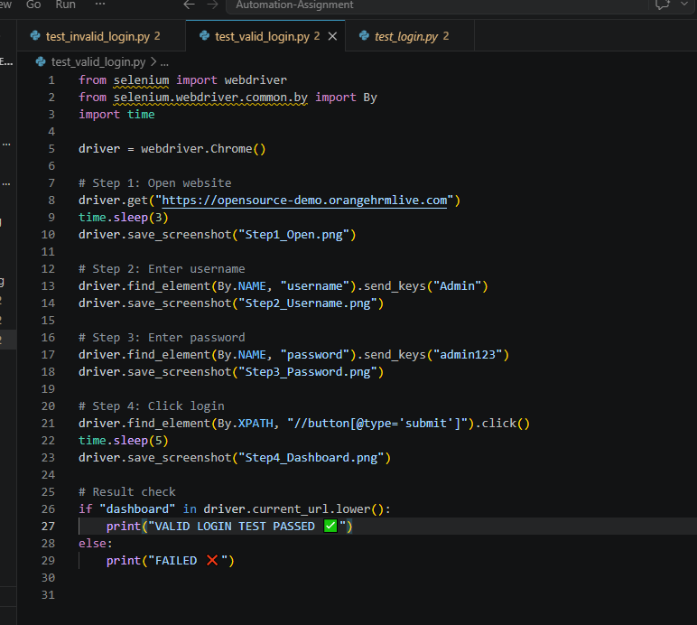
OUTPUT
- Open Chrome browser
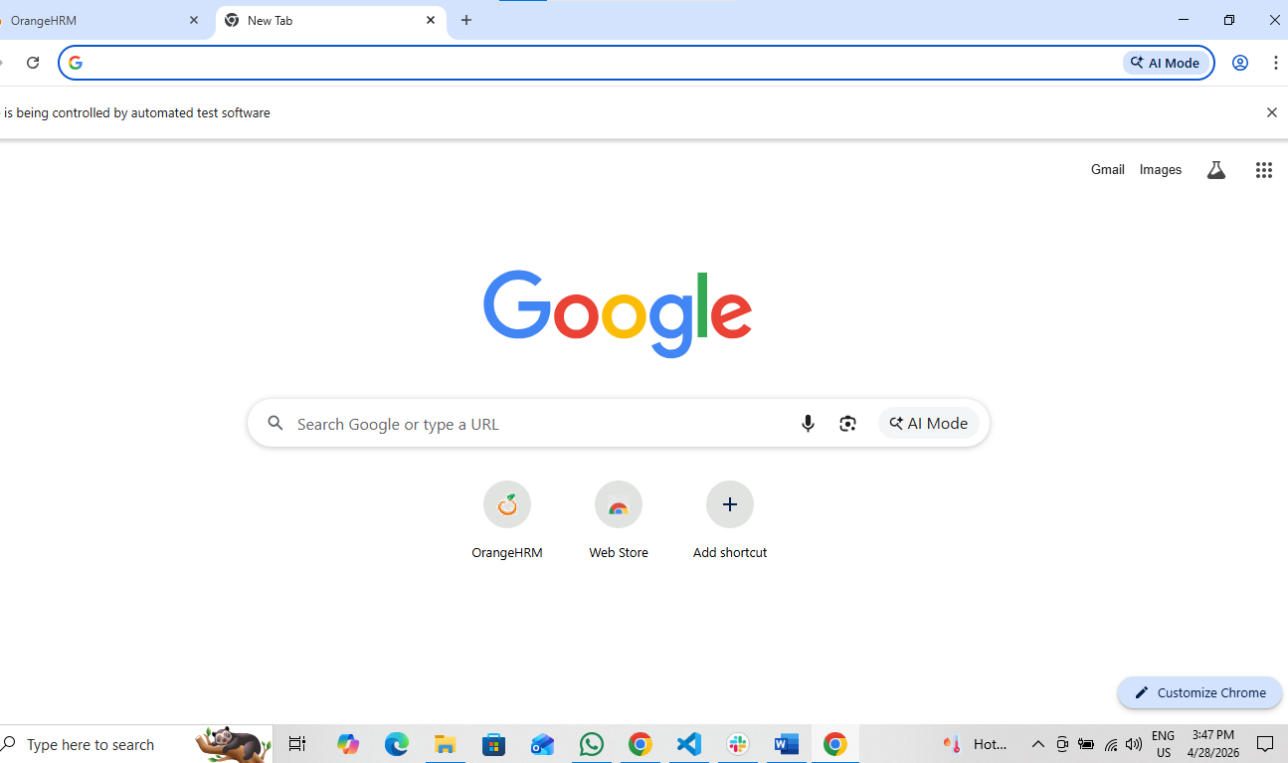
- Open OrangeHRM website
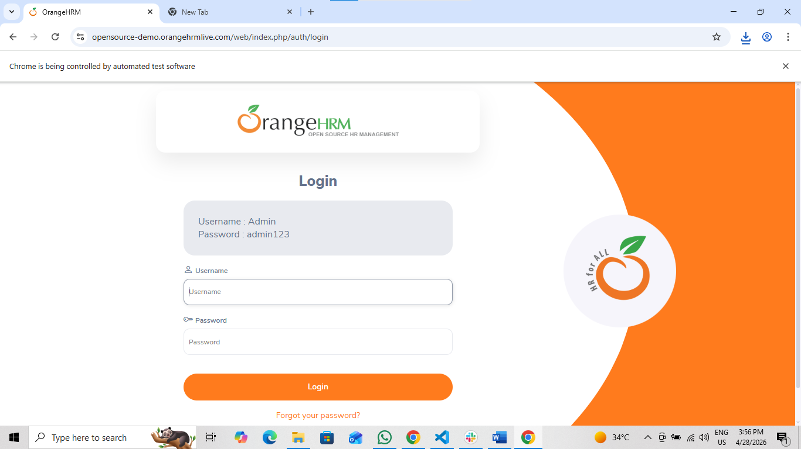

- Enter Username: Admin and Password: admin123
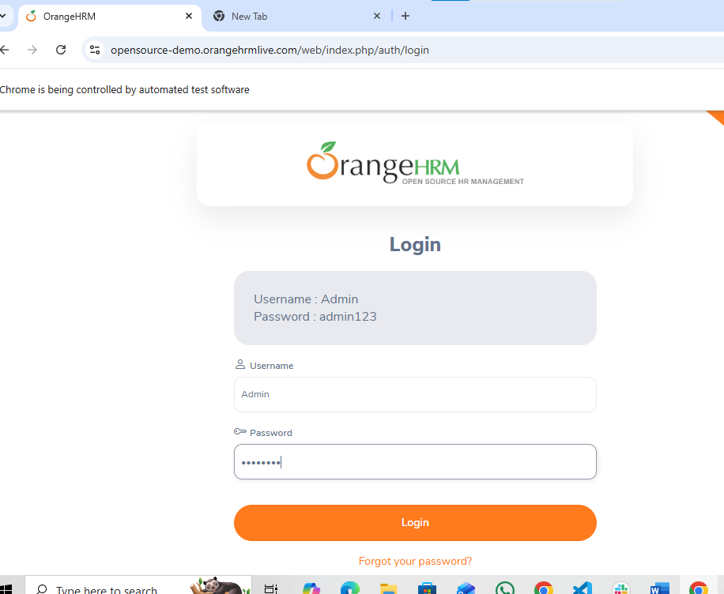
- Click Login button
LOGIN Successfully
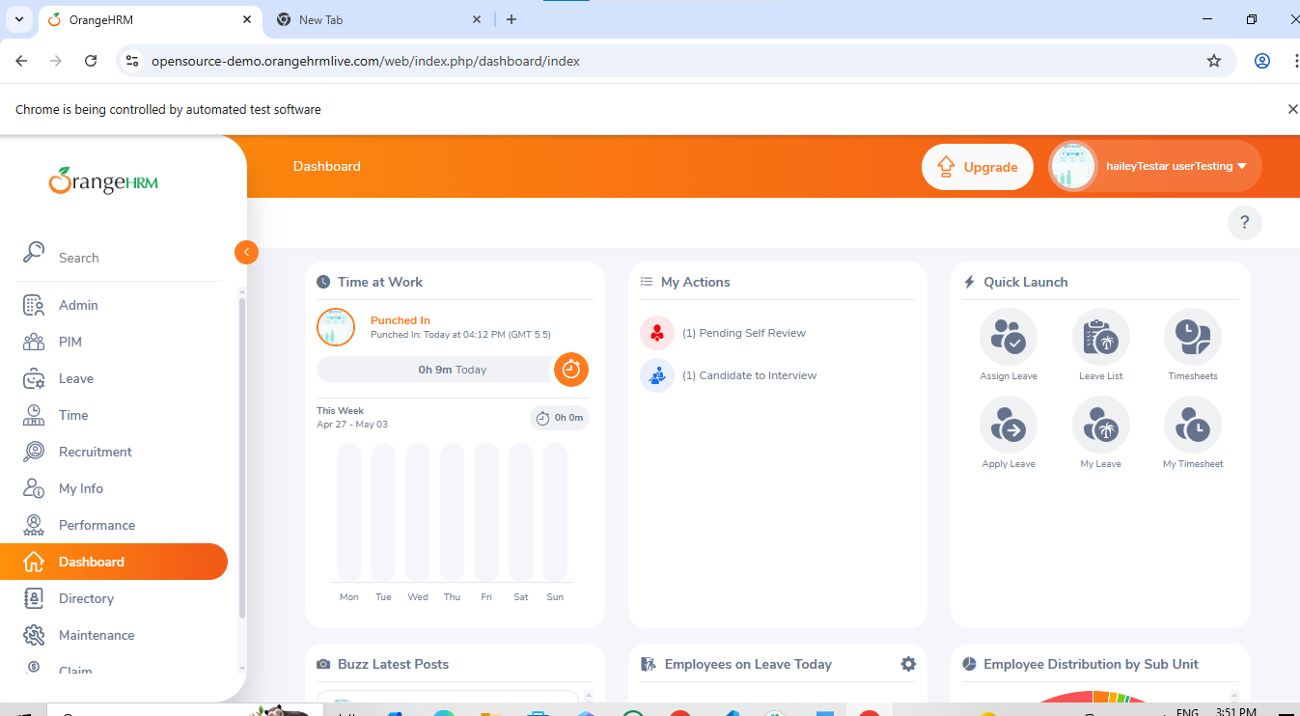
Expected Result:
Dashboard should open successfully
Actual Result:
Dashboard opened successfully
Status: PASS
TEST CASE 2: INVALID LOGIN
CODE:
Test_invalid_login.py:
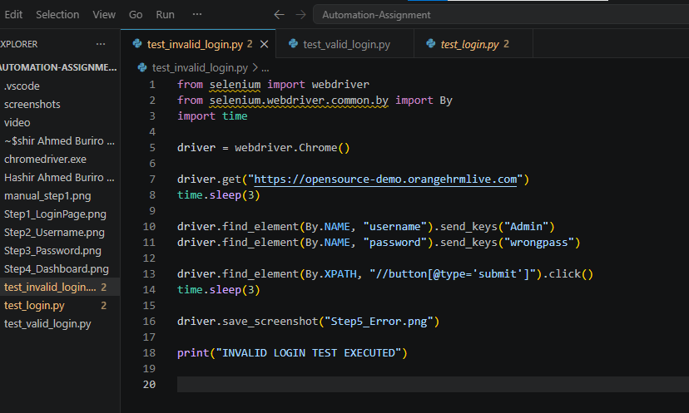

Output:
- Open OrangeHRM website

- Enter Username: Admin and Enter incorrect password
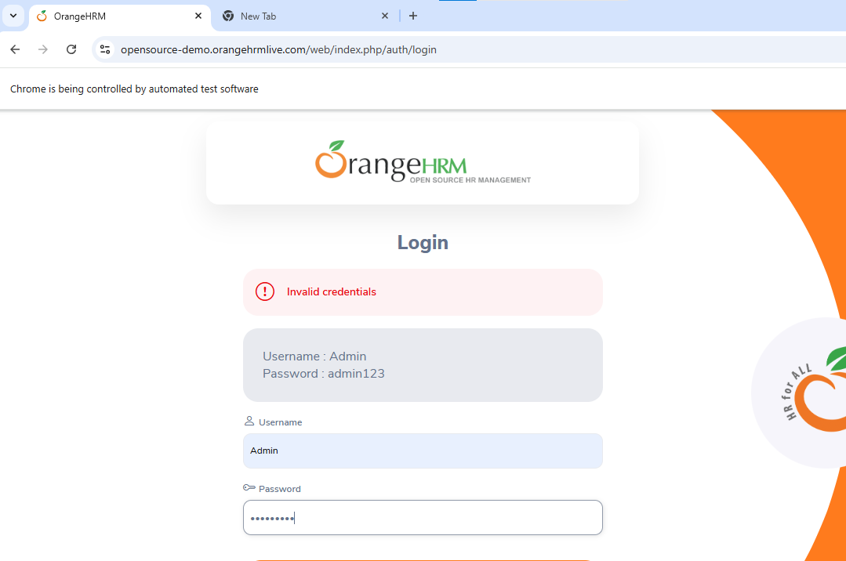

- Click Login button
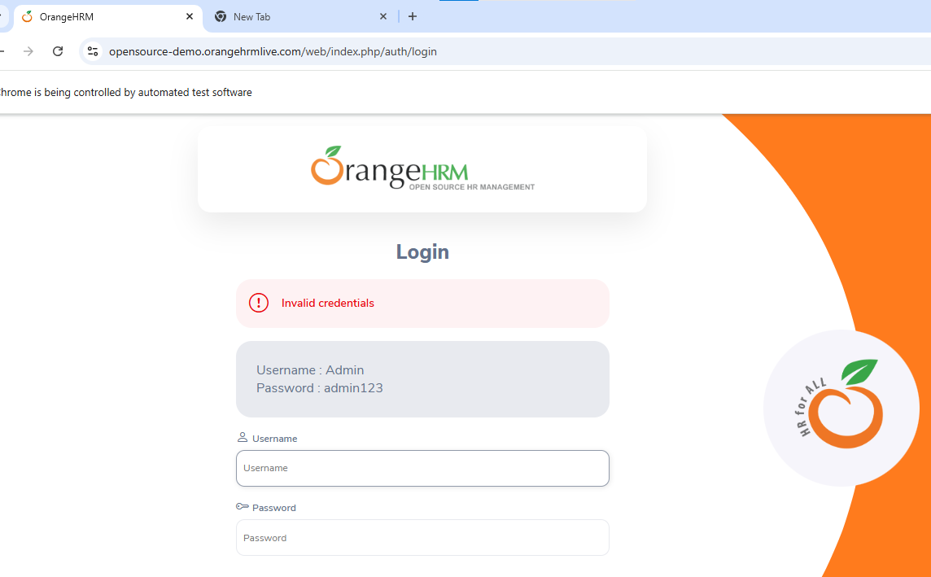
Expected Result:
Invalid Credentials
Actual Result:
Error message displayed successfully
Status:
PASS
RESULT:
The automation script executed successfully. The application opened correctly, login credentials were entered automatically, and the dashboard loaded successfully.
Benefits of Manual Testing:
- Verifies real user behavior and user experience
- Helps identify usability and interface issues
- Ensures application functionality works correctly
- Useful for validating both positive and negative test scenarios
- Improves software quality before deployment

CONCLUSION:
Automated regression testing was successfully performed on the OrangeHRM demo web application using Selenium WebDriver with Python. The automation script executed all test steps correctly, including opening the browser, navigating to the website, entering login credentials, and verifying successful login functionality.
The test results confirmed that the application responded correctly to valid login inputs and the dashboard loaded successfully after authentication. The automation process reduced manual effort and ensured accurate and repeatable testing.
This project demonstrated how automation testing improves efficiency, saves testing time, and supports reliable regression testing for web applications.

